**Create a build using Git and maven through Jenkins Pipeline:**

1. Go to Git hub repository and click on createn new file:

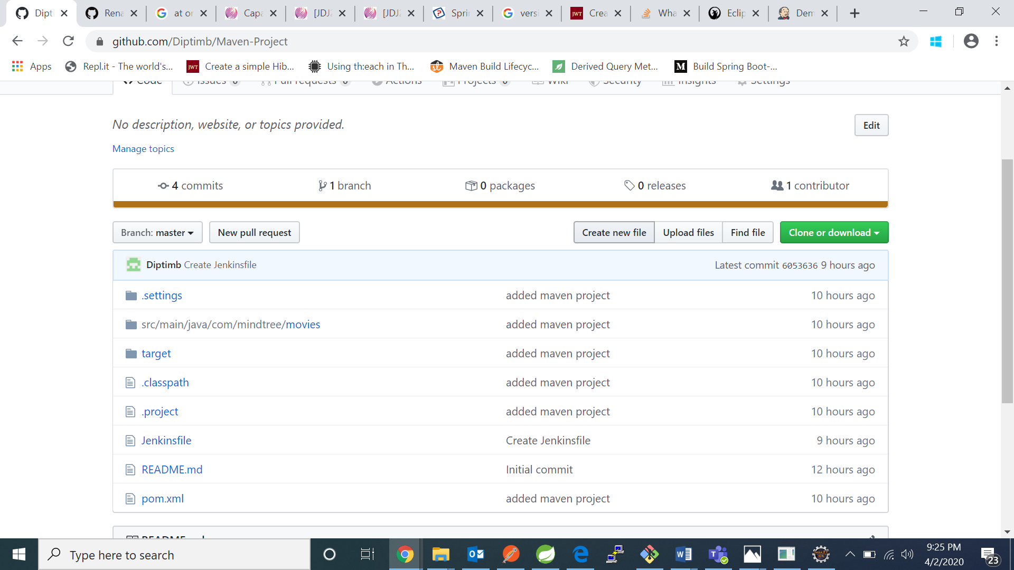

1. Create a Jenkinsfile named file and write the following code in it: 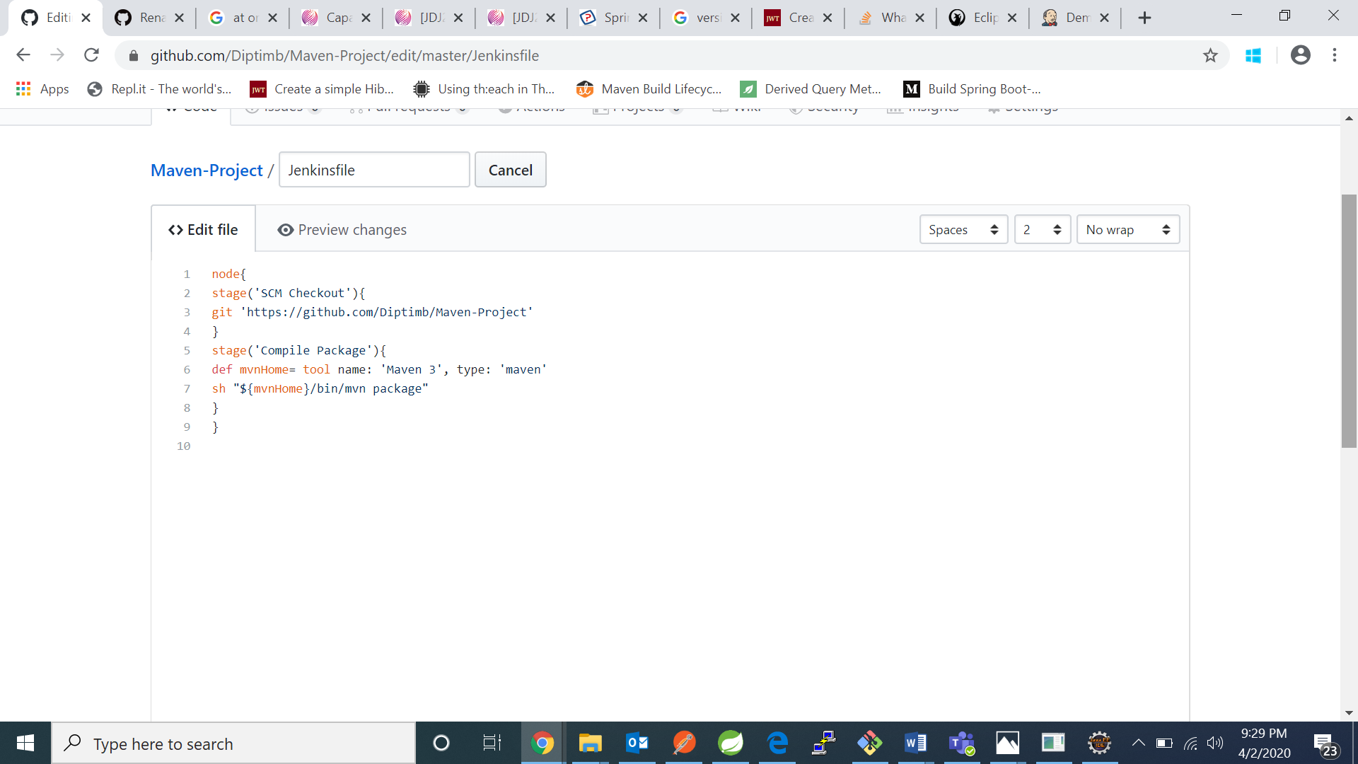
2. Now open the jenkins portal and click on new item

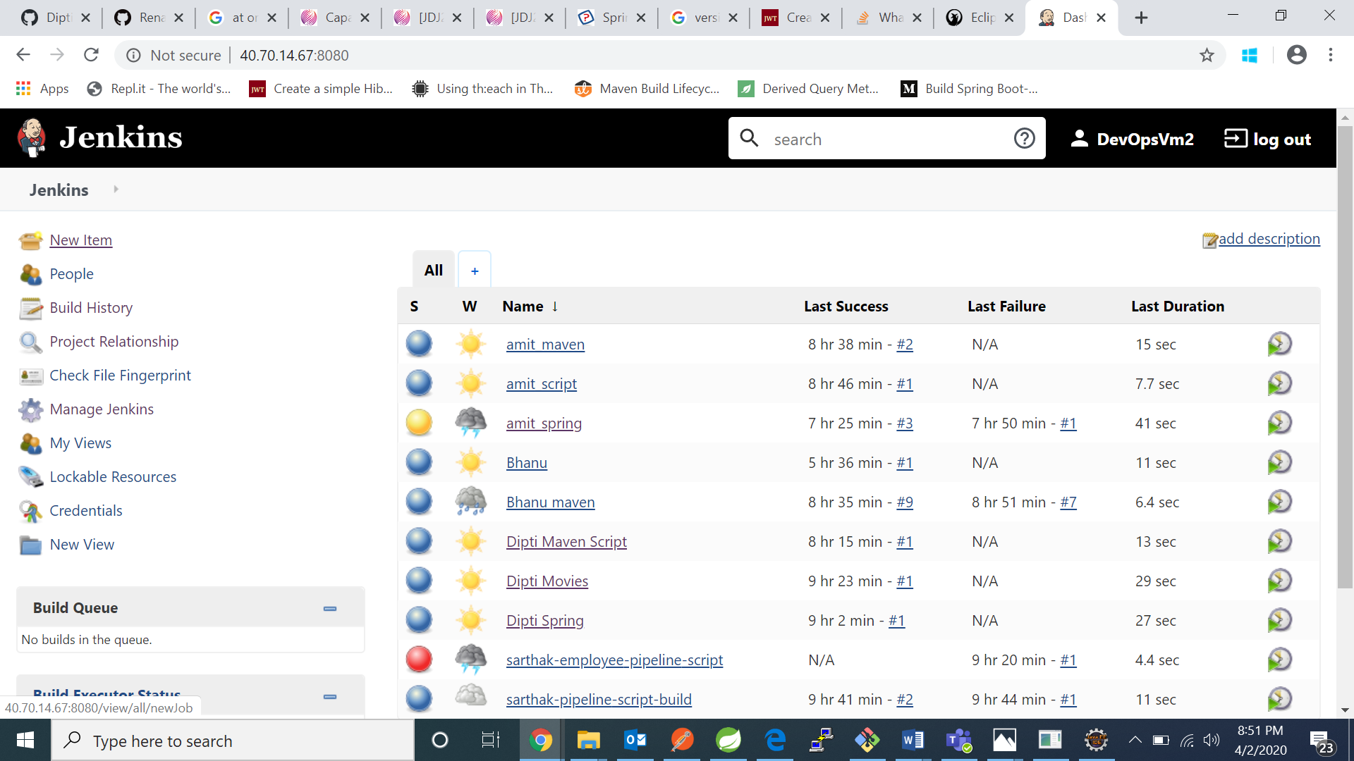

1. Now enter a project name and click on pipeline and click on ok:

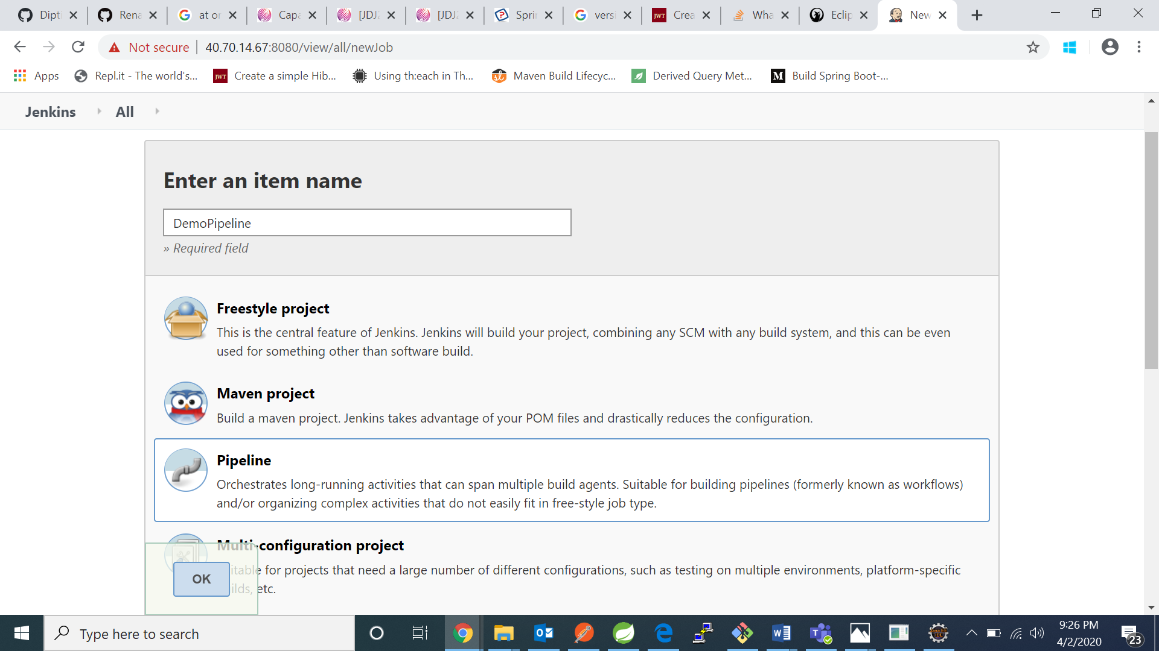

1. Go to Pipeline tab 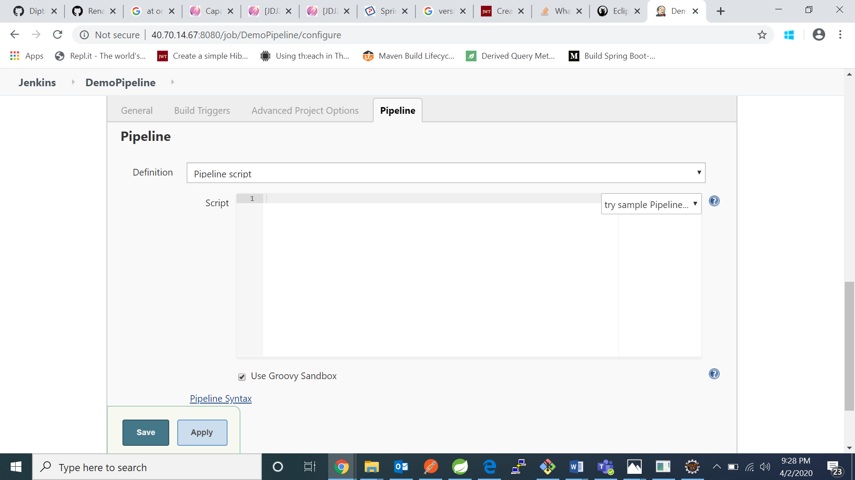
2. Got to definition and click on Pipeline script from SCM:

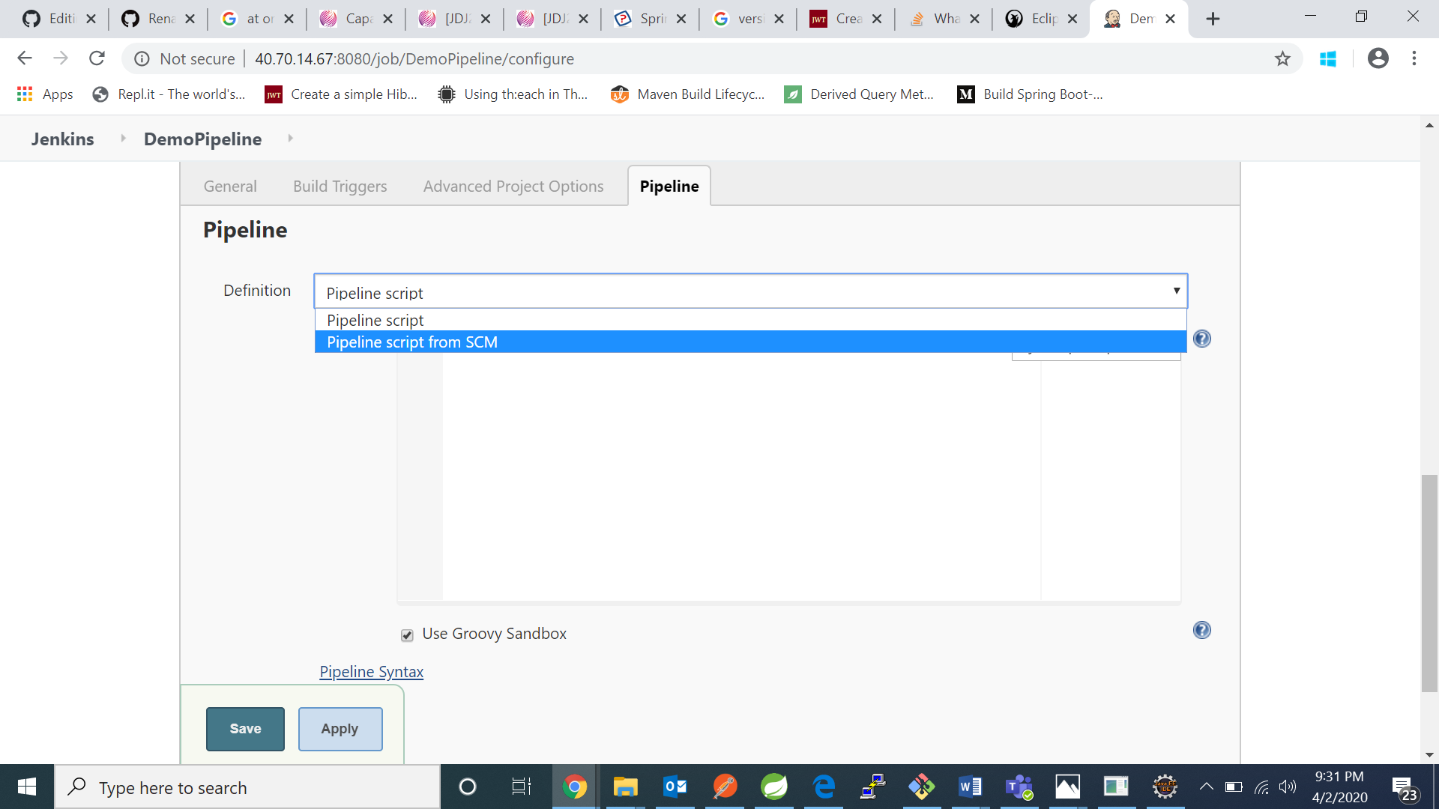

1. Now in SCM tab click on Git , in the URL enter GitHub repository URL and click on save.

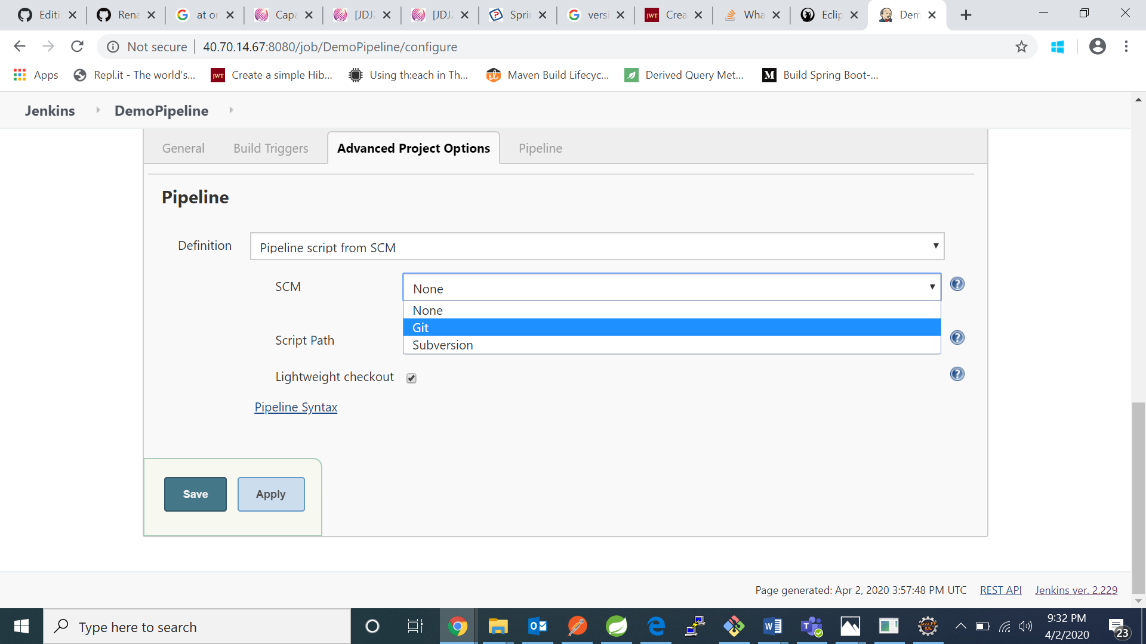

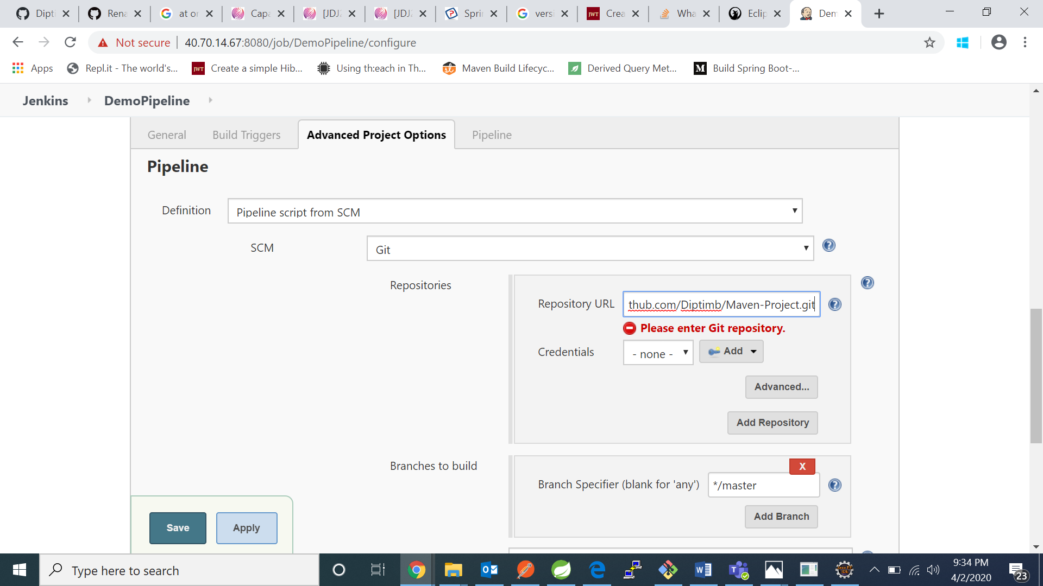

1. Maven project is created

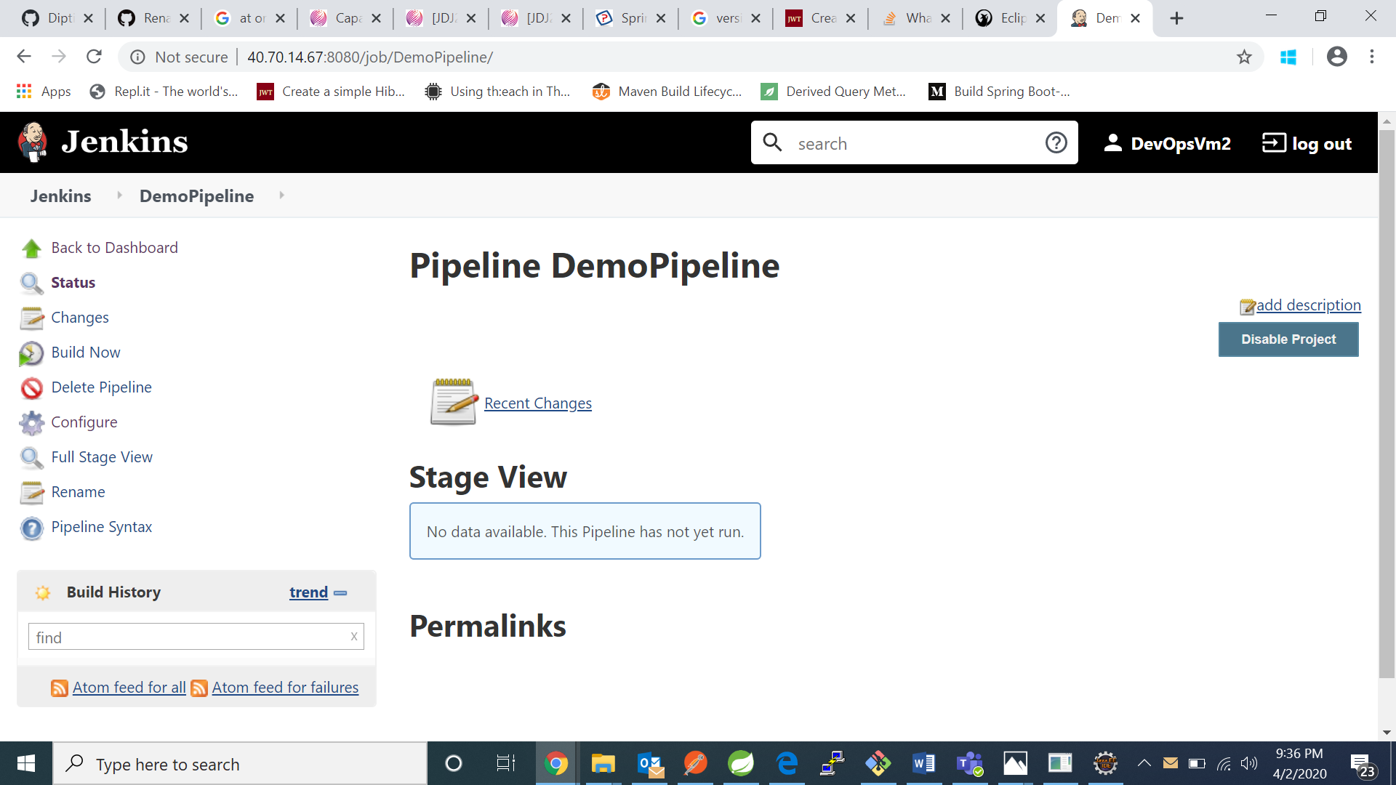

1. Now click on build now: 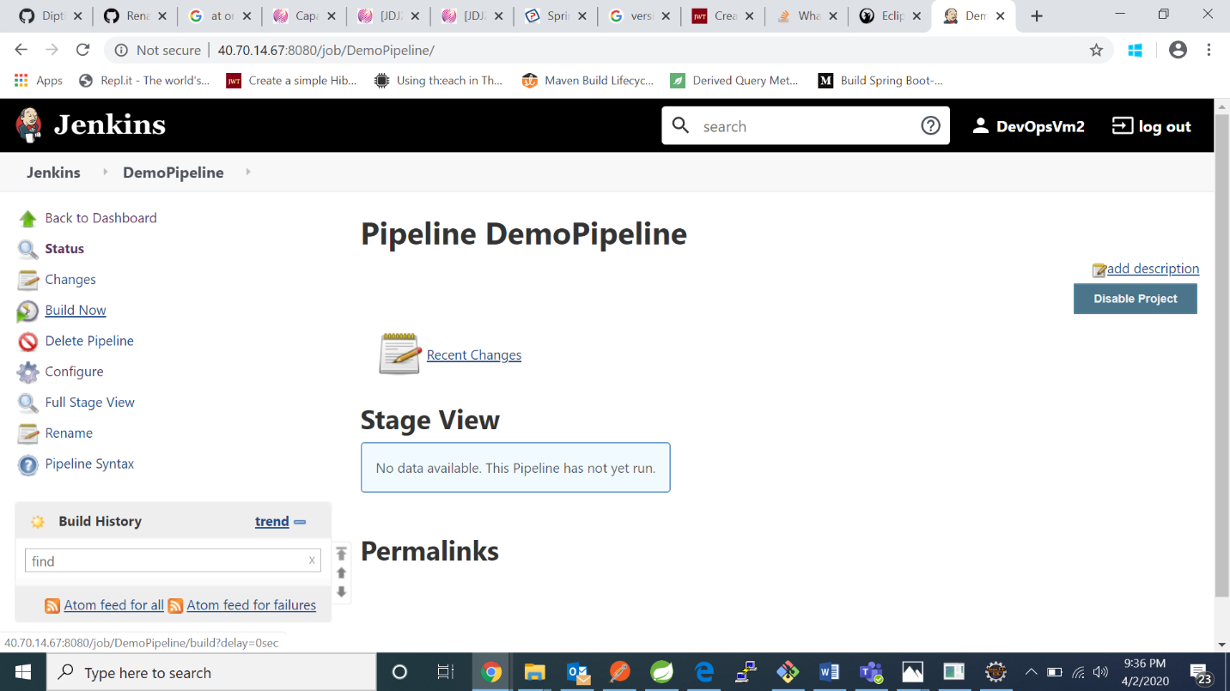
2. We can see the project is building in below:

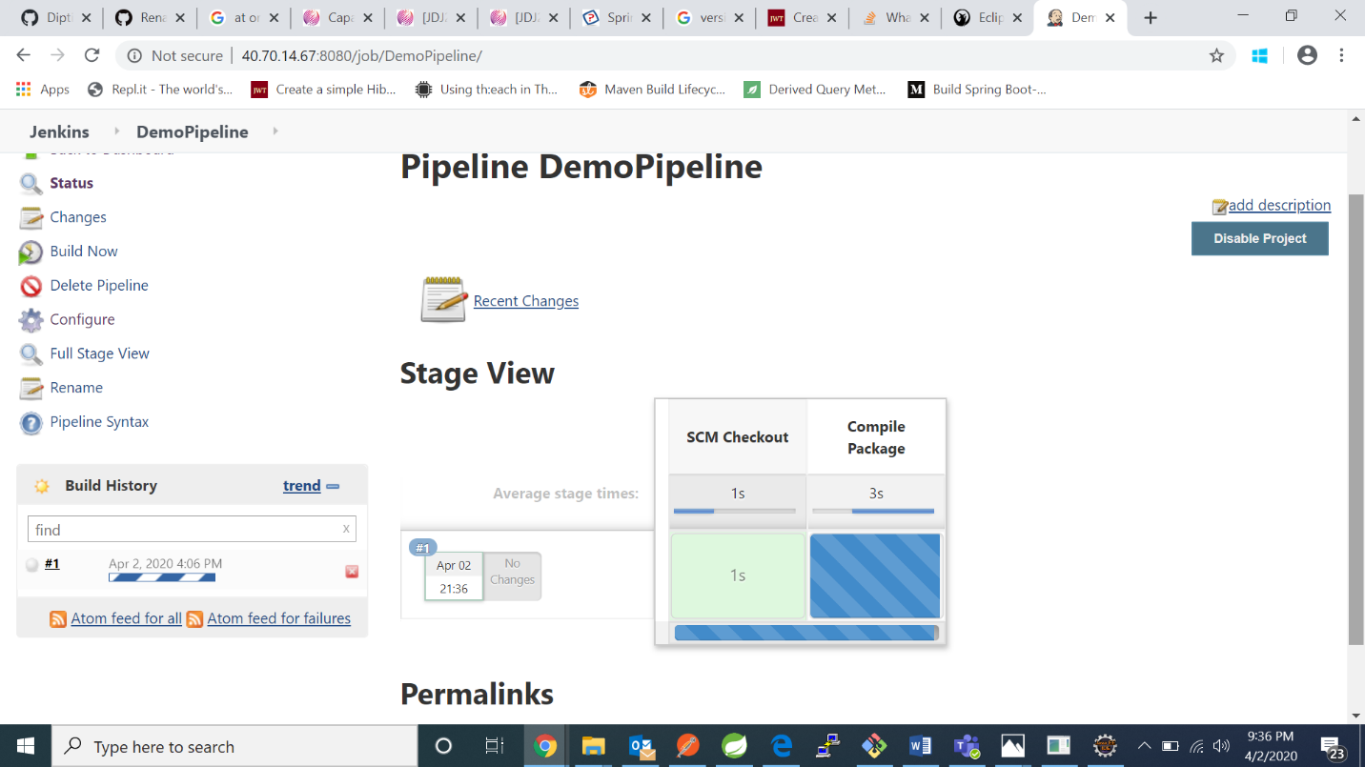

1. I got this result on console output: 